import java.util.Scanner;
public class One {
public static void main(String[] args) {
try (Scanner scan = new Scanner(System.in)) {
System.out.print("Enter the size of array: ");
int size = scan.nextInt();
int[] array = new int[size];
System.out.print("Enter elments (space - separated): ");
for (int i = 0; i < size; i++)
array[i] = scan.nextInt();
System.out.print("Array: ");
for (int i = 0; i < size; i++)
System.out.print(array[i] + " ");
}
}
}

Code:
Question 1:
Write a Java program to insert 10, 20, 30 ....in an array and display them.

Week 5

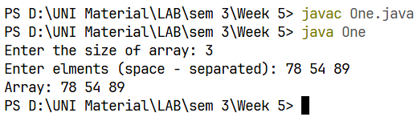
Output:

Question 2: 1
Code:
Write a Java program to calculate the sum of all the array elements.

import java.util.Scanner;
public class Two {
public static void main(String[] args) {
try (Scanner scan = new Scanner(System.in)) {
System.out.print("Enter the size of array: ");
int size = scan.nextInt();
int[] array = new int[size];
System.out.print("Enter elments (space - separated): ");
for (int i = 0; i < size; i++)
array[i] = scan.nextInt();
int sum = 0;
System.out.print("Array: ");

System.out.print("Array: ");
for (int i = 0; i < size; i++) {
sum += array[i];
System.out.print(array[i] + " ");
}
System.out.println("\nSum of all elements: " + sum);
}
}
}

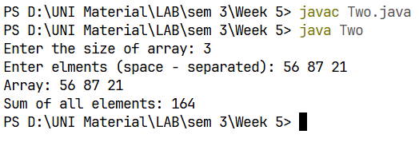
Output:

12345
1
12
123
1234
Question 3:
Write a java program to print the following pattern.

12
123
1234
12345

import java.util.Scanner;
public class Three {
public static void main(String[] args) {
int n;
try (Scanner scan = new Scanner(System.in)) {
System.out.print("Enter the number of rows (n): ");
n = scan.nextInt();
}
for(int i = 1; i <= n; i++){
for(int j = 1; j <= i; j++)
System.out.print(j + " ");
System.out.println();
}
}

Code:

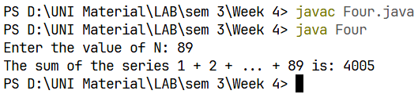
Output:
Question 5:
Write a Java program to take a number, divide it by 2 and print the result until the number becomes less than 10

Code:
import java.util.Scanner;
public class Five {
public static void main(String[] args) {
try (Scanner scan = new Scanner(System.in)) {
System.out.print("Enter a number: ");
int number = scan.nextInt();
if(number < 10)
System.out.println("Number is less than 10, please enter more than 10");
while (number >= 10) {
System.out.print(number + " / 2 = " + (number/2) );
number = number / 2;
}
}
}
}

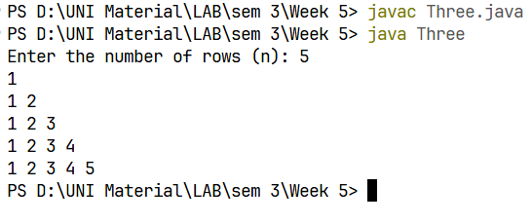
Output:

import java.util.Scanner;
public class Four {
public static void main(String[] args) {
int n;
try (Scanner scan = new Scanner(System.in)) {
System.out.print("Enter the number of terms (n): ");
n = scan.nextInt();
}
double sum = 0.0;
for(int i = 1; i <= n; i++)
sum += 1.0/i;
System.out.printf("Sum of series: %.4f", sum);
}
}

Code:
Write a java program to find the sum of following series where n is input by the user. 1+1/2+1/3+1/4+...............+1/n.

Question 4:

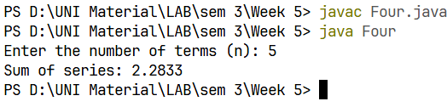
import java.util.Scanner;
public class Five {
public static void main(String[] args) {
int num;
try (Scanner scan = new Scanner(System.in)) {
System.out.print("Enter an integer: ");
num = scan.nextInt();
}
int sum = 0;
int temp = num;
while (temp > 0) {
sum += temp % 10;
temp /= 10;
}
System.out.println("Sum of digits of " + num + " = " + sum);
}
}

Code:
Question 5:
Write a Java program and compute the sum of the digits of an integer.

Output:
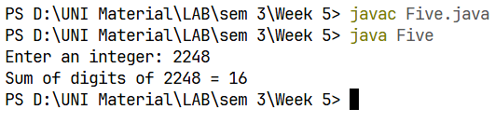
Output:
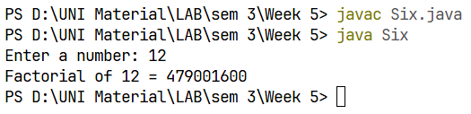
Optional
Question 7:
Write a Java program to find the largest element in a given integer array

Code:
import java.util.Scanner;
public class Seven {
public static void main(String[] args) {
int size;
int[] array;
try (Scanner scan = new Scanner(System.in)) {
System.out.print("Enter the size of array: ");
size = scan.nextInt();
array = new int[size];
System.out.print("Enter elments (space - separated): ");
for (int i = 0; i < size; i++)
array[i] = scan.nextInt();
}

Output:
import java.util.Scanner;
public class Six {
public static void main(String[] args) {
int n;
try (Scanner scan = new Scanner(System.in)) {
System.out.print("Enter a number: ");
n = scan.nextInt();
}
long fact = 1;
for (int i = 1; i <= n; i++)
fact *= i;
System.out.println("Factorial of " + n + " = " + fact);
}
}

Code:
Write a Java program to calculate the factorial of a number.

Question 6:
int largest = array[0];
System.out.print("Array: ");
for (int i = 0; i < size; i++) {
System.out.print(array[i] + " ");
if (array[i] > largest)
largest = array[i];
}
System.out.println("Largest element: " + largest);
}
}

Code:

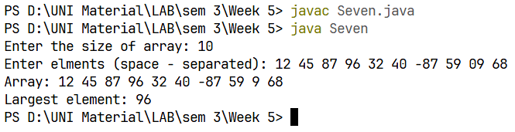
Output:

Code:
Write a Java program to reverse the digits of a given integer.

Question 8:
import java.util.Scanner;
public class Eight {
public static void main(String[] args) {
int num;
try (Scanner scan = new Scanner(System.in)) {
System.out.print("Enter an integer: ");
num = scan.nextInt();
}
int reversed = 0;
int temp = num;
while (temp > 0) {
reversed = reversed * 10 + (temp % 10);
temp /= 10;
}
System.out.println("Reversed number: " + reversed);
}
}

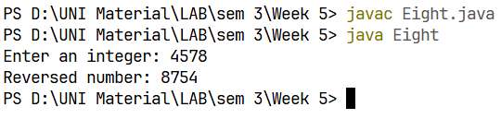
Output:
import java.util.Scanner;
public class Nine {
public static void main(String[] args) {
System.out.print("Enter an integer: ");
int num;
try (Scanner scan = new Scanner(System.in)) {
num = scan.nextInt();
}
int reversed = 0;
int temp = num;
while (temp != 0) {
reversed = reversed * 10 + (temp % 10);
temp /= 10;
}
if (num == reversed)
System.out.println(num + " is a palindrome.");
else
System.out.println(num + " is not a palindrome.");
}
}

Code:
Question 9:
Write a Java program to check if a given number is a palindrome or not

Output:
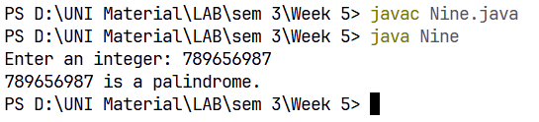
import java.util.Scanner;
public class Ten {
public static void main(String[] args) {
System.out.println("Select one operation: ");
System.out.println("1. Decimal to Hexadecimal");
System.out.println("2. Hexadecimal to Decimal");
System.out.print("Enter your choice (1-2): ");
int choice;
Scanner sc = new Scanner(System.in);
choice = sc.nextInt();

Code:
Write a Java program that takes a number as input and prints all its factors

Question 10:
Output:
switch (choice) {
case 1 -> {
System.out.print("\nEnter the number (decimal): ");
int num = sc.nextInt();
String hexStr = "";
if (num == 0)
hexStr = "0";
else {
while (num > 0) {
hexStr = switch (num % 16) {
case 10 -> "A" + hexStr;
case 11 -> "B" + hexStr;
case 12 -> "C" + hexStr;
case 13 -> "D" + hexStr;
case 14 -> "E" + hexStr;
case 15 -> "F" + hexStr;
default -> (num % 16) + hexStr;
};
num /= 16;
}
}
System.out.println("Hexadecimal: " + hexStr);
}
case 2 -> {
System.out.print("\nEnter the number (hexdecimal): ");
String hex = sc.next();
int decimal = 0;
int power = 0;
for (int i = hex.length() - 1; i >= 0; i--) {
char c = hex.charAt(i);
int value = 0;
if (c >= '0' && c <= '9')
value = c - '0';
else if (c >= 'A' && c <= 'F')
value = c - 'A' + 10;
Code:

else if (c >= 'a' && c <= 'f')
value = c - 'a' + 10;

decimal += value * Math.pow(16, power);
power++;
}
System.out.println("Decimal: " + decimal);

}
default -> System.out.println("Invalid choice! Please run again.");
}
sc.close();
}
}

Code:
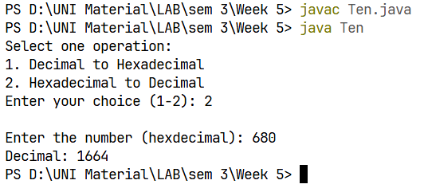
import java.util.Scanner;
public class Eleven {
public static void main(String[] args) {
try (Scanner sc = new Scanner(System.in)) {
System.out.print("Enter number of total number of rows (must be odd): ");
int h = sc.nextInt();
int mid = (h + 1) / 2;
for (int i = 1; i <= h; i++) {
int stars = (i <= mid) ? i : h - i + 1;
int spaces = mid - stars;
for (int j = 1; j <= spaces; j++) {
System.out.print(" ");
}

*
*
**
***
**
Code:
Write a java program to print the following pattern:

Question 11:
Output:
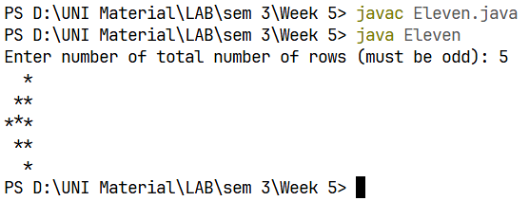
Output:
for (int j = 1; j <= stars; j++) {
System.out.print("*");
}
System.out.println();
}
}
}
}

Code:

